

Sri Lanka Institute Of Information Technology
Travel Map Asia Offline Booking System
Software Requirement Specification

Information Technology Project 2013

Project ID: ITP-13-B4-11

Submitted by:

- IT12115112– Fernando M.K.R.
- IT12121984– Sajith B.C.
- IT12062270– Tennakoon T.A.K.D.
- IT12058006– Nirmali T.A.M.
- IT12026180– Peiris T.G.D.
- IT12022502– Thenuwara C.R.
- IT12042920– Kanchana J.A.B.C.
- IT12054114– Wijewardhana K.A.T.D.

Submitted to:

…………………………..

Mrs. Anjalie Gamage

02-08-2013

Table of Content

1. Introduction 1
1.1 Purpose 1
1.2 Document Conventions 1
1.3 Intended Audience and Reading Suggestions 2
1.4 Product Scope 3
1.5 References 4
2. Overall Description 5
2.1 Product Perspective 5
2.2 Product Functions 6
2.3 User Classes and Characteristics 7
2.4 Operating Environment 8
2.5 Design and Implementation Constraints 9
2.6 Project Documentation 10
2.7 User Documentation 10
2.8 Assumptions and Dependencies 11
3. External Interface Requirements 12
3.1 User Interfaces 12
Error and Warning Messages 13
3.2 Hardware Interfaces 26
3.3 Software Interfaces 26
3.4 Communications Interfaces 27
4. System Features 28
5. Other Nonfunctional Requirements 43
5.1 Performance Requirements 43
5.2 Safety Requirements 44
5.3 Security Requirements 45
5.4 Software Quality Attributes 45
5.5 Business Rules 47
6. Other Requirements 48
Appendix A: Glossary 50
Appendix B: Analysis Models 51

Revision History
Name | Date | Reason For Changes | Version

Introduction

Purpose
The purpose of this Software Requirements Specification (SRS) document is to present a clear and precise description of the functionality of the Travel Map Asia Offline System, and to eliminate ambiguities and misunderstandings that may exist. For the customer, the SRS explains all functions that the software should perform. For the developer, it is a reference point during software design, implementation and maintenance.

The SRS divides the system requirements into two parts, behavior and non-behavioral requirements. The behavioral requirements describe the interaction between the system and environment. Non-behavioral requirements relate to the definition of the attributes of the product as it performs its functions. This includes the level of security, efficiency, reliability, maintainability, portability, capacity, and the standards of compliance of the product. The intended audience of the SRS is and the development teams. This document serves as an agreement between both parties regarding the product to be developed.

Version Number: 1.0.0 / v 1.0.0
This document covers the full system scope to be implemented as finalizing the product compromising its delivery standards.

Document Conventions
Stating the document conventions, it is adhered to IEE documentation. Also the full document is drafted using the font “Times New Roman”. It is been highlighted or rather given with appropriate picture examples throughout the documents whenever necessary. Also note the bolded words carry significant and important aspects that need to be addressed along. The requirement analysis is described both via point where the statement have its own priority.

Font | Times New Roman
Font Size | 12 - General
Bolded Text Body | Major Function Attentions  Priority: Developers
Heading | Main Areas  Font Size: 14
Sub Headings | Sub Areas  Font Size: 12
Underlined Text | Points Under Classification
Highlighted Text Area | System Functioning Guidelines

Intended Audience and Reading Suggestions
The document is released targeting its readers from both client “Red Stone (Pvt) Ltd” and the software development team. This shall reach the following intended audience,
- Project Manager, To look into final analysis and secure the full legal infrastructure.
- Developers, A hard coded analysis of the design to be implemented.
- Marketing – To market the product given with its wide scope.
- General Manager of Red Stone (Pvt) Ltd.
- Alpha users ie: Two designated tour guides, when testing.
- Document Writers.
The document contains an overview of the proposal submitted initially, the rest of the SRS is documented to serve its rightful purpose so to address the areas that looked into when developing “Travel Map AOB1.0”. It’s been looked into to
- Overall Description
- External Interface Requirements
- System Feature
- Other Nonfunctional Requirements
- Other Requirements
and shall be describing further in to each topic through the rest of reading.
It most suggetsted to read along the topics mentioned staring from the introduction and go thorugh each area. The document is prepared in a way so to capture each angle of the product that is to be implemented. It is been tried to remove ambiguity and be rather specific when coming up with solutions, describing functions, user handling etc.

Product Scope
Travel Map Asia offline booking system, the system that we are going to develop is an application with online integration. It will be helpful for the customers who are not interested in online reservation systems because of additional charges and problems in security of private and confidential details. And also the tour operators will be benefitted with this system through the features of the system.
The main feature of the system for the tour operators is that we are going to introduce credit limits for the reservations done by them. The limit will be decided according to the contract and other business rules & regulations between the tour operator and the hotel. The system administrator (internal user), who is in the developing company of the system, is responsible for the maintainability of the credit limit. After receiving a note from the hotel, he can update the credit limits for the tour operators.
Other than that tour operators can search details of the hotels & rooms according to the customer’s choice, and they can have their own inventory and rates for each hotel. Tour operator can decide the room rates that he is going to sell, after adding his charges to the hotel charges. And also the cancellation process of hotel reservations, is one of the main functions of this system. According to the day of cancellation and hotel policies, cancellation process will be processed.
Through this system, efficiency and managing details of tour operators will be increased. And they can avoid form manual and repetitive work. Because of different user levels the security of information will be guaranteed.

References
Book References
[1] Software Engineering I Text Book
Personal Interview/Communication References
[2] Interview [or Personal Communication] with Ms. Anjalie Gamage.
[3]Interview with the Managing Director of Red Stone Pvt. Ltd.


World Wide Web

[4] www.google.lk

[5]www.facebook.com


[6] User’s Guide: Microsoft Word, Vers. 5.0, Microsoft, 1991.
[7] http://redstonebiz.com/
Wikipedia Entry (http://en.wikipedia.org)
No author mentioned
[8]”Business Proposal”, Wikipedia.

Overall Description

Product Perspective
This product is being implemented to go along with the full functioning online reservation system which is TRVEL MAP ASIA. The will run alone as a standard system which will have online implementation only for email notifications and submissionds and for limit upgradings.
Red Stone Biz Pvt. Ltd. Is requesting for this specific solution because of the conflicts they face with in dealing with clients in online contract handling and the profit challenges as they get involved with a GDS for the ongoing process.

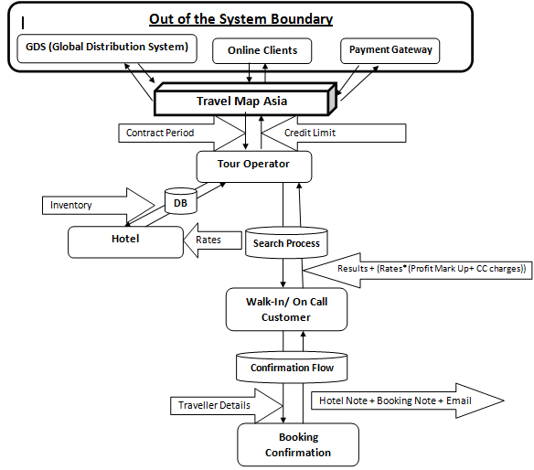

Figure 1: General High Level Diagram of the proposed system.

Product Functions
There are mainly 8 functions that cover up the entire schedule of work of the system.

User Authentication & Authorization
Users are at two levels in the system.
- Internal User – Performs the system administration and maintenance
- Tour Operator – Do the reservations with the configured system under an agreement with a credit limit allocated
Tour operators are given contracts as identified in the agreements with the company. Once the contract expires the system will auto block the user from logging further into the system. A tour operator can deals with reservations subjected up to a credit limit offered. Once it is exceeded he/she won’t be able to proceed till the credit limit is updated by the Internal User. For updating, full payments should be done. And additionally they have to pay charges applied by the company at a total cost as for the reservations calculated.
Hotel Search Results
Tour operator can search for hotels as prior to the customer requirement. They could provide with various details as suggested by the customer. For an instance the customer may ask for a hotel specifying a city or a country, with reference to star ratings of hotels, facilities provided, budgets etc. Here the user can generate searches and also perform filtering as suggested by the customer need. Also sorting could be done in orders, as referred with availability, ratings, location etc.
Hotel Inventory & Rate Handling
Tour operators come with agreements with the hotels distinctly. Agreements are not important for the company which the users are responsible of. So an individual operator may maintain his/her own list of hotels. For that the system is facilitated to add inventory for each hotel separately. Also the rate calculations are important. Usually a hotel suggests its charge and the company charges a fee from the tour operator for each reservation he/she handles. This is called the call center fee which is a percentage. This is because initially when providing the solution to the operator the company does not charge vaguely. Tour operator has the facility to add his/her own profit markup and the final price given for the customer is generated as a combination of them all.
Reservation Confirmation Flow
When a reservation is done customer details are be maintained and in the system. Cash flows are not indicated but it’s important to generate confirmations to avoid conflicts of understanding. A letter of booking is automatically generated and is sent to the hotel for their references. Similarly an invoice is sent to the customer as a letter of booking confirmation. This may be handed to the customer as a hard copy as his/her requirement and regardless, a soft copy is sent via email to the customer.
Hotel Search & Cart Handling
Searches can be done as the customer need and the results are generated as integrated with the second function mentioned above. The algorithm of searching is highly handled at this state. A customer can do more than a single reservation at a time. And it is facilitated with the cart scenario where a single payment process could relate in all and separate confirmations are generated. Calculations are also handled using specific algorithms and methods.
Reservation Cancellation & Hotel Information Display
Reservation cancellations are done according to a policy which the customer generally comes in agreement at a specific reservation. The refunding is calculated and is handled accordingly. The policy is clearly indicated to avoid conflicts and it includes the charge which has to be paid for the hotel if a reservation is cancelled. And also the call center fee and the profit markup for the tour operator is added at the generation of the cancellation deduction.
Hotel Details Controlling
Tour operators can maintain details of hotels with this functionality. They could maintain a collection of images if required. The contract information regarding hotels could be maintained at this section. Those contracts are useful at rate calculations.
Room Combination & Passenger Combination Handling
A room is identified as a combination of Room type and Bed Type. The rate plan is generated
accordingly. Passenger combination specifies the number of passengers in a selected reservation and allocating passengers into rooms fulfilling occupancy integration

User Classes and Characteristics
In the system there are two types of users.
- Internal User
- Tour Operator

With the system reference words Our Client/Main Company is called the Call Centre. They sell the system to Tour Portal. Tour Portal can have one or more Tour Operator & it may have one or more Internal Users.

Internal user is the one who acts as the admin. Internal user is capable of doing
Internal User account creation
User password reset
Tour Operator account Creation
Permission Granting

But Internal User will not be able to do the Bookings.

Tour Operator is the one who has the ability to do the bookings. Tour operator has a specific contract period. If this contract expires, the relevant tour operator will not be able to log in to the system.

When the contract expires, Tour Operator will have to request from the call centre for the contract updating with the relevant TO name. Then the company will look is the payments for the TO has been successfully transferred to them. If it is, then they will email external updating software to the Portal & from the portal end they have to run it with the Internal User Permissions. That will update the contract for the relevant Tour Operator.

Tour Operator also has a profit mark-up. This will be the profit for the Tour Operator.

Operating Environment
Travel Map Asia Offline Booking System requires following requirements to develop and run the system properly.

Hardware Requirements
- 2GHz Processor (32bit or 64bit) or higher
- 2GB RAM or higher
- 1GB Available hard disk space (minimum)
- Screen Resolution should be at least 1024x768

Software Requirements
- Windows XP Professional Service Pack 3 x86(32bit)/ x64(64bit)
or Windows Vista Service Pack 2 x86(32bit)/ x64(64bit)
or Windows 7 or Windows 7 Service Pack 1 x86(32bit)/ x64(64bit)
or Windows 8 x86(32bit)/ x64(64bit)





Design and Implementation Constraints
Specific Tools and Technologies | Description
NetBeans IDE 6.9 | NetBeans is an integrated development environment (IDE) for developing primarily with Java It is also an application platform framework for Java desktop applications and others.
PostgreSQL 9.0 | PostgreSQL, often simply Postgres, is an object-relational database management system (ORDBMS) available for many platforms.  This is used to create all the database tables and store data inserted that will flow through the system.
iReports 3.7.1 | The software that generates certain reports of all kinds for all the information that is stored in the databases.

design conventions or programming standards
Red Stone Biz is a software development company itself. They are willing to destribute the system as a product benificial to the company. So the client is responsible of maintaining the delivered software system.

Project Documentation
The initial document created was the project charter that included a brief introduction about the software product and names and given tasks of the developing team.

Project proposal was compiled as the second document which contained the outline of the proposed solution and the overall system architecture. The system architecture diagram pictorially described the layout of the system.

This Software Requirement Specification (SRS) being the 3rd document, contain more description of how the system is being developed and how the system is to function. This document will contain requirements (both functional and non-functional), Use Case diagrams, Use Case Scenarios, Activity diagrams and ER. This document will describe how each user level will affect the rights available to the user.

The Introduction and how to use this software will be provided to the client as training with standard formats and guidance.

User Documentation
All the itemizations that the user needs to know about how to operate the system is shown in section 3.1, which is the introduction of all the user interfaces in the product. This system is very user friendly and all the guidance will be provided in the program, once provide a training for user levels, we hope that this will be very easy for handle and we are available on line for any kind of support.

Assumptions and Dependencies
This product is an Travel Map Asia Offline Booking System and there will be transaction procedures and it is assumed that they all will be done in Sri Lankan currency unit (Rupee).
The system contains hardware and software dependencies that were mentioned in section 2.4, which is the operating environment to work with. No need to purchase or other project tools/programs to run this system and majority of 90% software’s will be open source.

External Interface Requirements

User Interfaces
This section contains the specification of requirements for interfaces among different components of the system and their external capabilities. It presents a high level of abstraction of the basic elements of the Graphical User Interface (GUI) and the display screens of the system. The design and implementation teams may define specific command buttons, list boxes, radio buttons, text fields, and pull-down menus to meet the requirements. The system interface is mainly described in terms of a login screen, main screen, Hotel Setup-Info, Lookup Info and Inventory and Rates screen.
General Interface Requirements
- All windows shall display a title with the names of the system: Travel Map Asia Offline System.
- All windows shall include a minimize button, a maximize button, and a close button at the top right corner.
- Maximized windows shall include a restore button at the top right corner and no maximize button.

Login Screen
- The Login screen of the system displays the following text: Welcome to Travel Map Asia Offline System.
- The user shall have to enter the user name and the password to login into the system
- The user shall have the option to select the Login mood: Standard or Secure.
- The user shall have the option ‘Remember my login’.
- The user shall have the option to recover the password if it is forgotten. This provides with email verification which the user have to provide the userID and the system will automatically send an email with login details of the user.

Main Screen
- The interface displays the following test: “Welcome to Travel Map Asia Offline System. You are logged in as ******** . © RedStoneBiz All rights reserved. Rel.Version V 1.0.0 Rel.Date: **-Month-2013

Hotel Setup
- The Hotel Setup has the following tabs which will display different forms and interfaces to the user.

Hotel Setup – Standard
- The user shall have the facility to enter a hotel record into the system. This is classified into two main areas.
- Hotel Name and Address Information – The user shall have the facility to provide all the necessary details of a specific hotel under this section.
- Other Details – This section includes some understandings between the hotel and the user and categorization of a specific hotel.
- When a booking is made and the booking is needed to be confirmed with the hotel, the user need to select Send Booking Acknowledgement. This will indicate to the customer that the booking needs to be confirmed with the hotel and a subsequent email will be sent which would be the final confirmation. This is in effect a two step confirmation process to confirm booking. If the booking can be immediately confirmed, you need to select Send Final Confirmation, which is a one step confirmation process.
- The user shall provide with contact information prior to the hotel record.

Error and Warning Messages
- The system shall display error message prompts if any invalid input or data is considered as erroneous and/or incomplete.

- Message Dialog

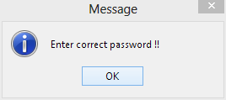

Figure2: Error Message Prompt

This is an interface of how the user gets the warning messages.

- Confirm Dialog
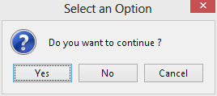

Figure3: Option selection
This is an interface of how user gets the Confirmation options.

- Input Box
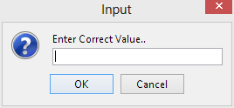

Figure4: Input prompt
This is an interface of how user gets the Input messages.
- Login Window
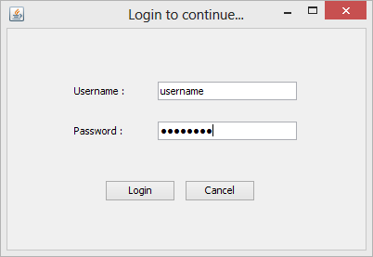

Figure5: Login Interface
Shortcut Keys
Tab - Switch between components
Enter - Performs Login Action
Esc - performs Cancel Action
Button Functions
Login Button - Sign in to the System.
Cancel Button – Exits from the System.

First of all the user must log in to the system in order to do any changes or view the system. This is the Login interface for it.

- Hotel Setup – Standard Details

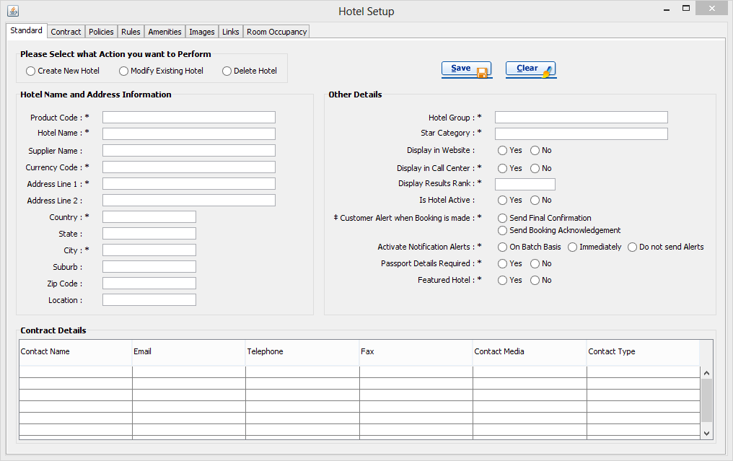

Figure6: Hotel Setup Structure

Shortcut Keys
Tab - Switch between components
Enter - Performs Save Action
Button Functions
Save Button - Validate the fields and insert data into the database.
Clear Button - Clear all the fields after the user confirms.

This interface is for collect the standard details about the hotelSuch as Hotel name, Address, Country, Contact Details, Hotel Group and Many other details.

- Hotel Setup – Contract Details
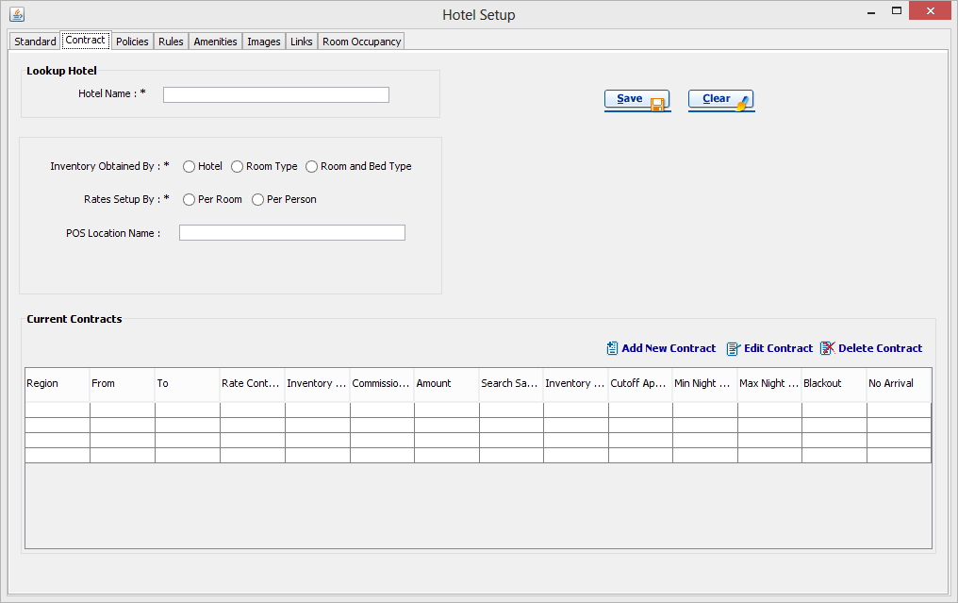

Figure7: Hotel Setup Structure
Shortcut Keys
Tab - Switch between components
Enter - Performs Save Action
Button Functions
Save Button - Validate the fields and insert data into the database.
Clear Button - Clear all the fields after the user confirms.
Add New Contracts – Opens new interface for the enter details of the contract details.
Edit Contract - Opens new interface for the Edit details of the selected contract.

This interface is for collect the details about the Contract Details of the Hotel. User can add new Contract details & can Edit or Delete any existing contract details using this interface.

- Hotel Setup – Policies

Shortcut Keys
Tab - Switch between components
Enter - Performs Save Action
Button Functions
Save Button - Validate the fields and insert data into the database.
Clear Button - Clear all the fields after the user confirms.
Add New Policy – Opens new interface for the enter details of the Policy details.
Edit Policy - Opens new interface for the Edit details of the selected Policy
Add New Charge - Opens new interface for the enter details of the Charge details.
Edit Charge - Opens new interface for the Edit details of the selected Charge.
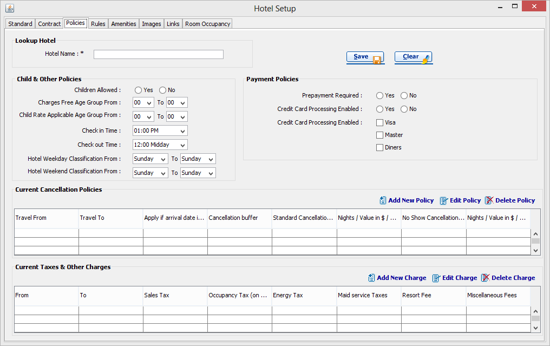

Figure8: Hotel Setup Structure

This interface collects details about the policies of the hotel such as cancellation policy, Child and Other policy, Payment policy, Taxes and Other Charges.

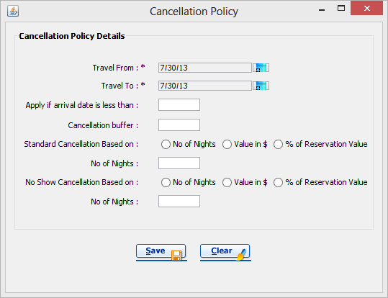
- Cancellation Policy

Figure9: Policy creation for cancelation

This is the interface of making the Cancellation Policies.

- Taxes & Other Charges
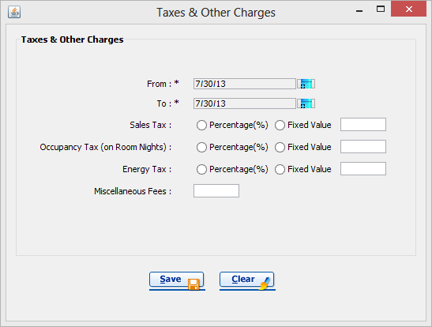

Figure10: Calculations for taxes

This interface collects some valuable details about the Taxes and other Financial Charges.

- Hotel Setup – Rules

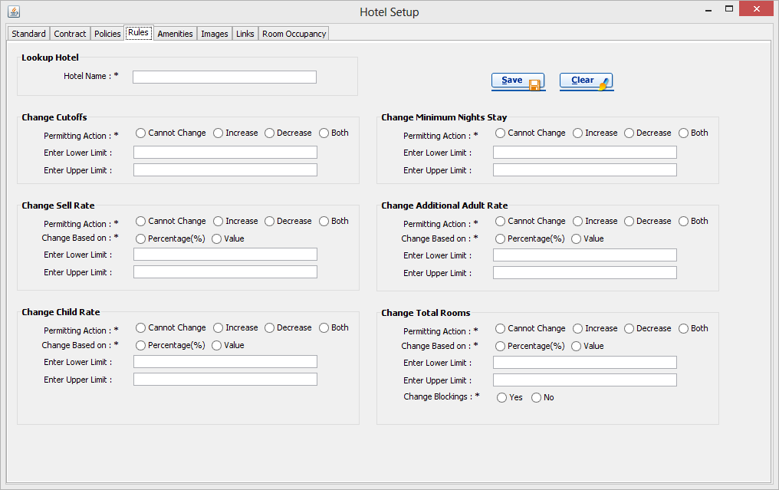

Figure11:Hotel Setup Structure

This is the interface of making some important Rules of the Relevant Hotel.

- Hotel Setup – Amenities

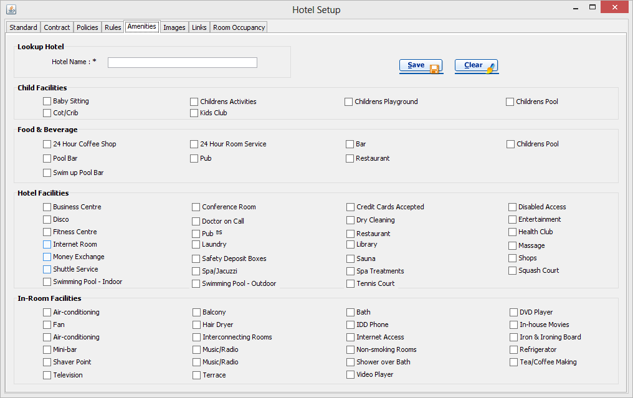

Figure12: Hotel Setup Structure

This interface collects information about the hotel’s available Facilities such as child Facilities, Food & Beverage, Room Facilities and Hotel Facilities.

- Hotel Setup – Image
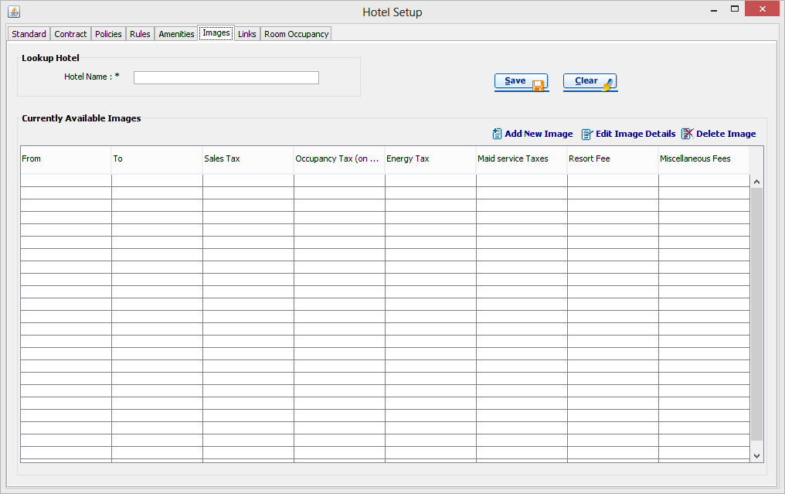

Figure13: Hotel Setup Structure
Using this interface users can store the images and photos of the hotels. User can see the all available images of the hotel from this interface.

- Upload Image

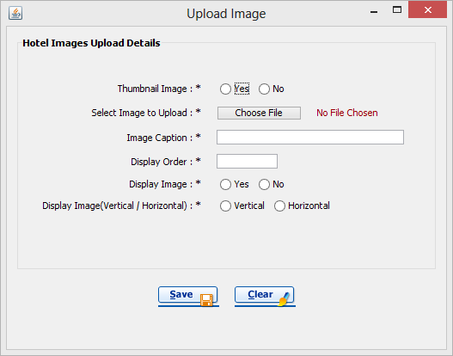

Figure14: Image upload wizard

Using this interface users can insert the images of the Hotel to the System.

- Hotel Setup - Links
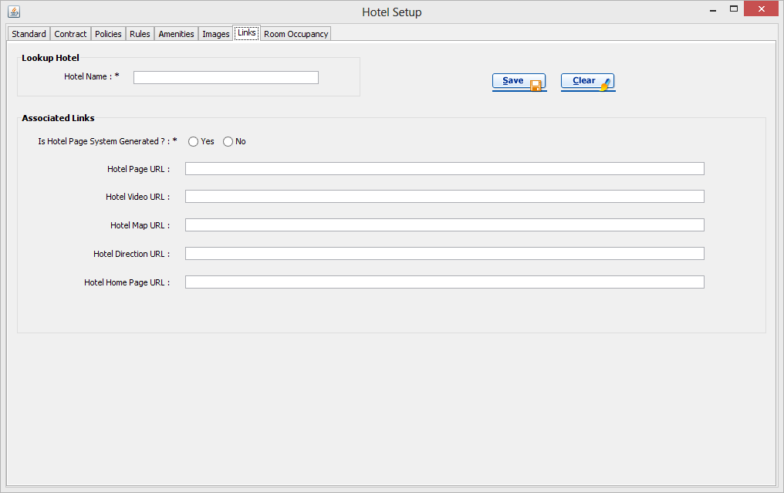

Figure15: Link Integration
This interface collects the information about links of the image such as Hotel Map URL, Hotel Home page, Hotel Video URL etc…

- Hotel Setup – Room Occupancy

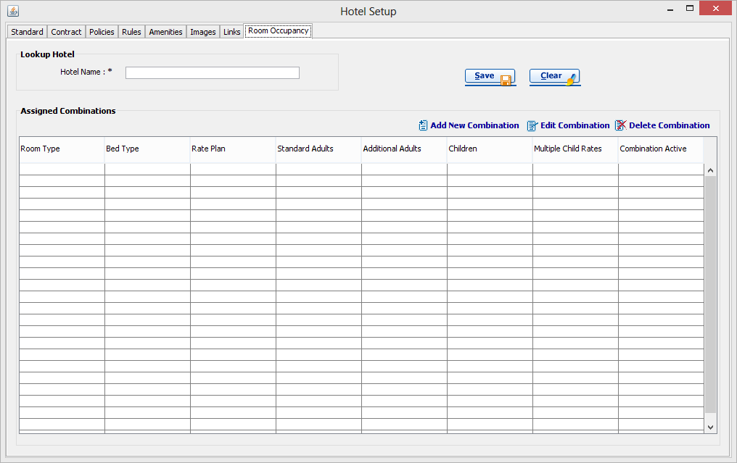

Figure16: Hotel Setup Structure

Users can view the combinations of Room & Bed types and Hotel Rates and some other important details.

- Assign Room Occupancy
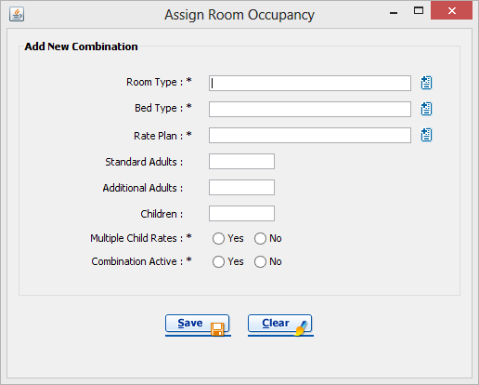

Figure17: Room Occupancy

This is the interface of assigning the Room Occupancies to the hotel such as Room Type, Bed Type, and Child Rates etc…

- Room Type

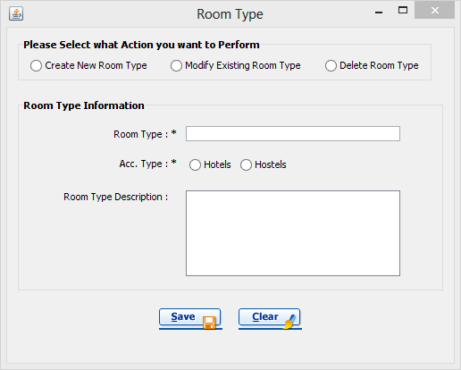

Figure18: Room Type chosing

From here users can create the new Room Types or Edit and Remove Existing Room Types for the Travel Map Asia System.

- Bed Type
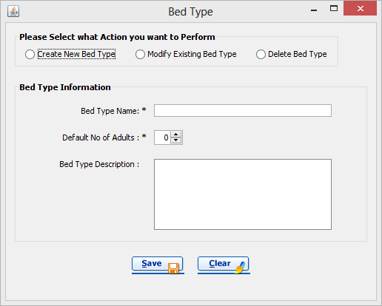

Figure19: Bed Type Handling

From using this interface users can create the new Bed Types or Edit and Delete Existing Bed Types for the Travel Map Asia System.

- Rate Plan
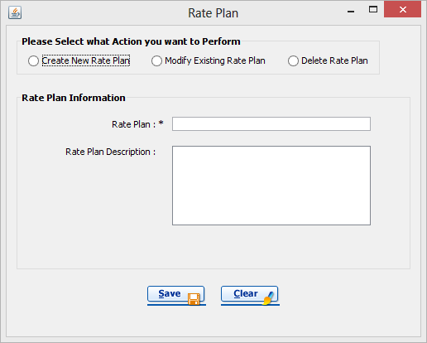

Figure20: Rate Plan Calculation

From using this interface users can create the new Rate Plans or Edit and Delete Existing Rate Plans for the Travel Map Asia System.

Note - Room types, Bed types & Rate plan types need to be setup in the Setup >> Lookup info section. If the necessary rooms / beds / rate plans are not already setup, click on the respective buttons to create them directly from this screen.

- This will open up the setup screen for the respective type.
- Create the necessary room / bed / rate plan types.
- Click �Save�.
- In the "Add new Combination" dialog box, select the room type from the lookup.
- Select the bed type from the lookup.
- Select the rate plan type from the lookup.
Note - Standard adults is the number of adults that is accommodated in a room for the standard charge. Additional adults will be accommodated with an additional charge. Additional adults may be children who are above the child age range defined by the hotel. Children will be those between the age range defined by the hotel for children. A separate rate will be charged for them. The total number of occupants in a room will be the addition of the number of standard adults and either the number of additional adults or children, whichever is higher. Refer the below table for details on how to fill in these values.
Room can occupy  (A=Adults, C=Children) | Standard  Adults | Additional  Adults | Children | Total  Occupants
3A, 2A+1C, 1A+2C | 1 | 2 | 2 | 3
2A, 2A+2C | 2 | 0 | 2 | 4
2A, 3A | 2 | 1 | 0 | 3
4A, 2A+1C | 2 | 2 | 1 | 4
- Start by filling in the number of children, this will be the highest number of children allowed in the room as per the contract.
- Thereafter, fill in the number of standard adults, this will be the lowest number of adults allowed in the room as per the contract.
Note - The number of Standard adults will be automatically selected according to the number selected when setting up the bed type. Change it if needed.
- Now fill in the number of additional adults, this will be the difference between the highest number of adults allowed in the room as per the contract minus (-) the number of standard adults.
- Selecting "Multiple Child Rates" as No will mean that the same rate will be repeated for all children staying in the room. Selecting it as Yes will enable the user to enter multiple rates for each child, up to a maximum of 4 children.
- Enable the combination in order to view and utilize it in other screens.
- Click �Save�.
- The entered combination will be displayed in the grid.
- Repeat these steps to add further combinations.

Hotel Availability & Rates - By Period >> Setup Inventory
Purpose:
Enter and Modify room inventory for a period of consecutive days.
This screen is generally used at the beginning of a contract period to enter inventory data and to overwrite (modify) already entered data.
Actions:
Enter and Modify Inventory.
- Select the hotel from the Look up, if it is not displayed automatically.
- Select the Rate Region that the inventory being entered applies to.
Note - Inventory can only be entered in line with contracts setup in the Hotel Info >> Contracts tab. if inventory needs to be setup for specific regions, the respective contracts need to be setup initially.
- If a Rate region is selected, it is possible to select a specific B2B Agent. This can be done via the Tour Operator field. In this case, the entered inventory will apply only to the selected agent.
- Select the date period for which the inventory is being entered for.
- Click on "View", this will refresh the screen and display the available room combinations.

Lookup Info >> Amenities & Accessible Facilities
Actions:

Create new Amenities & Accessible Facilities
- Select "Create a New Facility" option.
- Select one of the pre-defined Facility Groups.
Note - These are high level categories of amenities and facilities offered by hotels.
- Enter the name of the Amenity being created.
- Select one of the pre-defined Amenity Groups.
Note - These are categories of amenities and facilities offered by hotels. The amenities will be sorted by this category in the Hotel Info page.
- Click "Save".

Hardware Interfaces
- Printer
This Travel Map Asia System is using a printer for printing purposes and user will be able to get many kinds of reports using this hardware interface such as Invoices, Cancellation Notes, Cancellation policy Details etc.

Software Interfaces
- PostgreSQL
We developed the Database of the Travel Map Asia System using the PostgreSQL. It is Free and Open source Database Management System. PostgreSQL has very good security features, Reliability and high performance than other Database Management Systems.
- Java Runtime Environment 1.6 (or higher)
We developed the Travel Map Asia System using the Java Development Kit (JDK) 1.6 version. So it need at least Java Runtime Environment (JRE) 1.6 for the run the System.
- iReports 3.7.1 (or higher)
We developed the Reports of the Travel Map Asia System using IReports. So it is needed for generate Reports of the System such as Invoices, Cancellation Notes, and Cancellation policy Details and so much more...
- Microsoft Windows Operating System
Travel Map Asia System needs the Microsoft Windows Environment for the execution. It’s better to have the Microsoft Windows XP Service Pack 3 or later version of Windows to get the better output.

Communications Interfaces
- SMTP Protocol
Travel Map Asia System sends some valuable information such as Invoices, Policies, Refundable Details and Cancellation Notes to the clients and the Hotels over the emails. We used the SMTP Protocol for the send those emails using the Travel Map Asia System.
- HTTP Protocol

System Features

Configurations & Static data has to be inserted by the portal operators, before the full functioning system usage. Configuration data is mainly doing by the Call Centre before the system is hand out to the portal. But the static data such as city should have to be initially updated by the portal operator.

Portal Operators (both internal & TO users) can create hotels. Normally a hotel contracts with the portal. Then we have to map that hotel details to the backend. So with this process hotel information such as name, description, star rating has to be added initially. Added hotel has to be assigned to a specific city.

For one hotel multiple images can be uploaded as these images can be mailed to a relevant person at an inquiry.

Hotel also has a contract. If the hotel contract expires for the given search period, then that hotel will not come to the results.

One of the most major things in this process is the cancellation policy for the hotel. Cancellation Policy should be there for a hotel, if the hotel should come for the results. Cancellation Policy is inserted to a hotel as follows,

Buffer (days) Charge Type Value
10 Percentage 30
7 Percentage 30
5 Value 400
3 Percentage 30
2 Value 300
1 Percentage 90
0 Percentage 100

The buffer days 0 record is a must. It is the no show policy. For a valid cancellation policy it must include the no show policy & one or more cancellation charges. Normally hotel cancellation policy doesn’t change. So this is only a Add & Edit functionality. Delete function will not be there. But the edit functionality will be available only if the hotel has not been interacted for any booking transaction. If the portal needs to change the hotel’s cancellation policy & if the edit functionality is not there, then they have to make that hotel disableForSearch & then create that hotel as a new hotel with the new cancellation policy.

Then the portal has to enter the Room Types, Bed Types & Rate Plans. Normally when hotel contracts with the portal, they give the information about the available room & bed types and the available rate plans. Room is a combination of these three components. So portal is creating rooms with combining these three components.

Then the portal operator has to assign the created rooms for the hotel. When hotel contracts with the portal, they give them an allocation of rooms with the pax(passenger) count. Portal Operator is assigning the room to the hotel with those relevant adult & child pax.

Then the portal has to enter the inventory & rates for the assigned rooms for the hotels. First they have to select the hotel & then the room. Inventory and the Rates assigning is done by month vice. After selecting the room, they have to select the relevant month. Then the values will be displayed as a calendar. In those fields the Inventory / Rate will be entered & saved. Inventories & Rates will be managed separately for adults and children.

Those details are maintaining with daily values as with this kind of functionality special periods can be manageable. When a peak session comes in to action, the portal will be able to make their rates different for the relevant day. And if there is any kind of hotel closing day, then with the system portal can handle this blackout period.

If a hotel needs to come for the results then that hotel should contain balanced inventories & rate bigger than zero to get that hotel into the results. If the search goes more than one day, then the above scenario should be applied for all the days. If that fails even on one day, then that hotel will not come for the results for those criteria.
When a client comes to the Tour Operator to a do a booking, first the Tour Operator asks him/her about the destination. Then he goes to the Booking Engine (search screen) and enters the details of the destination & selects the check-in and check-out dates. Then tour operator enters the number of rooms needed & the adult count and the child count for the rooms. Maximum room count is three.

When the Tour Operator executes his search with the above search criteria, system will go through the hotels & find the hotels which will match the search criteria. To make that hotel come out in the results, above mentioned rates, inventory, cancellation policy & the contracts should be valid.

Then the hotels are displaying in the results page. The net rate of the hotel is calculated by the sum of the selected room/rooms. But the final value will be displayed as,

Net Rate + (Net Rate*TO Profit Mark Up/100) + (Net Rate*Call Centre Charge/100)

Call centre charge is defining by the call centre & they will include that in portal configuration.

If the search goes more than one day, then the above calculation will be go on those multiple days separately & it will take sum out of them. But there is a button below the value display and clicking on that we can have the daily rate display.

If the hotel has more than one room that fits to the search criteria, then that hotel will have a button named show more rooms. Clicking on that link will display a pop up and they can change their rooms by selecting the necessary room from that screen.

In the results page we can view hotel more info. In the hotel more info, images of the hotel, contact details & other information will be displayed. This information can be viewed to the walked-in customer or can be emailed to a relevant person who is inquiring.

In the results page the user can filter the results with the hotel name, star rating and the price. Price filter will be handled via a slider. For the hotel name filter it will only have the hotel names that came out from the results. Hotel name is a specific hotel filter. That will not have like filtering. It will suggest the hotel names came in the results & operator can select a name from that hotel & get that hotel only filtered.

There is A-Z and 0-9 hotel name filter. That will filter all the results those are starting with the specified character.

Minimum Value and the Maximum Value of the price filter will be dynamically generated by the minimum and maximum values of the result set.

Star Rating filter also will be generated dynamically by the values of the result set. Star ratings will be one to seven & if any value between that is not available in the result set, then that value will not come into the filer.

Results will be default sorted by the price. But there is an option to sort this with name, star rating also.

Then the operator will click add to cart button on the hotels that the client needs. For every new booking process it will generate a transaction key and it will be maintained from search to reservation.

When we add the hotel into the cart, cart will be auto synchronized & update the values. In the cart feature, the operator can always add hotel to the cart & remove hotels from the cart. Hotel Details can be viewed directly from the cart items also.

One booking can contain one or more hotels. One hotel can contain one or more rooms.

After adding the hotels to the cart operator has to click the checkout button. Then the system will proceed to the payment confirmation section. Here the operator has to enter the traveller details. Traveller Details has mainly two categories.
- Lead Passenger
- Room Passengers

Lead passenger is the one who the operator is doing the booking for. Lead passenger is the person that has the responsibility about the booking & all the negotiations and other transaction about the booking will be handled with the company only via him/her. First name, last name, email & the contact address of the lead passenger is needed for the continuation.

Room passengers are the one who are going to stay in the rooms. Only the first name & last name of the passengers are needed.

In the payments section it will generate the cancellation policy according to the given check in date & the booking date & will display in the payments page.

Then the operator has to click on the Confirm Payment button. This will do the booking confirmation process.

In the booking confirmation it will first check the balance of the inventories are really bigger than 0 for that specific hotels for those days. Then the system will continue to save the data. First it will save the reservation data & reservation information, then the traveller details. Then it will reduce the balance from the inventory.

After a successful confirmation system will generate multiple notes about the booking.
- Customer Confirmation Note
- Hotel Confirmation Note
- Travelling Voucher

Customer Confirmation Note consists of the basic details of the booking. It will just give basic details about the hotel & this note will mainly focusing about giving the policies, terms & all the confirmation details about the booking. This is a printable report and this will be emailed to the lead passenger.

Hotel Confirmation Note is the booking note that will be emailed to the hotel. This will contain the basic information about the check-in check-out dates, room details & lead passenger details. This also a printable report & will be emailed to hotel’s email.

Travelling voucher contains all the details about the travellers, hotel information & etc. This will be emailed to both lead passenger & to the hotel.

If a booking needs to be cancelled it has to be permitted by an internal user. Then the tour operator will select the relevant booking & will see that, is that booking is within cancellation policy or outside cancellation policy. If the booking can be cancelled then he will be displayed the cancellation policy of the hotel. Then the system will calculate the net cancellation fee according to the cancellation policy, cancelling date & the check-in date.

If the cancellation charging type is percentage it will be calculated as a percentage under the total booking fee & if the type is value, then it will take the row value as the net cancellation charge.

But when displaying the system will add mark-ups on the cancellation charge as follows.

Net Cancellation Fee + (Net Cancellation Fee *TO Profit Mark Up/100) + (Net Cancellation Fee *Call Centre Charge/100)

Then the cancellation confirmation will process & same as the booking confirmation this will run through a data saving process. But this will not change the inventory balance. Inventory balance cannot increase at any time as it a system policy, because hotels contracts with the portal as the allocation of the rooms are for single transaction based.

After the cancellation it will generate
- Customer Cancellation Note
- Hotel Cancellation Note

These notes will mention about the booking that has been made & it has been cancelled in the mentioned date. It will also state about the applying cancellation policy, the cancellation charge for the cancellation & the money that has been refunded.

With the reports of the system: tour operator & internal user can view the progress of the bookings that has been made. There are reports such as reservation report, booking list report, booking confirmation report, Cancellation report to view the booking details separately.

Tour operator has a specific credit limit. This is maintaining by the Call Centre when handing over. If the portal needs to change this the same process as the TO contract update goes & this will also need the internal user permission.

When a booking is made, at the confirmation time tour operator’s credit balance will be reduced with the net rate of the booking. When the credit limit is less than net booking value the relevant tour operator cannot do that booking.

At each time the system shutdown, the system will make a database backup & it will be stored in the database & also will be emailed to a relevant configured email address.

At the first time each day when the system starts it will automatically email a booking details report of the last date, to the call centre. This is called booking synchronization report.

Use Case Diagrams

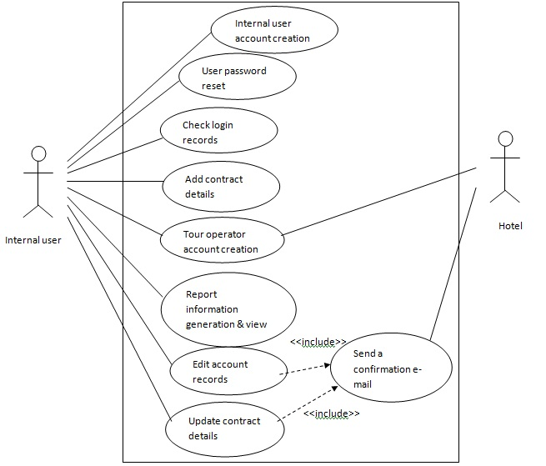

Figure21: Use Case Diagram - 1

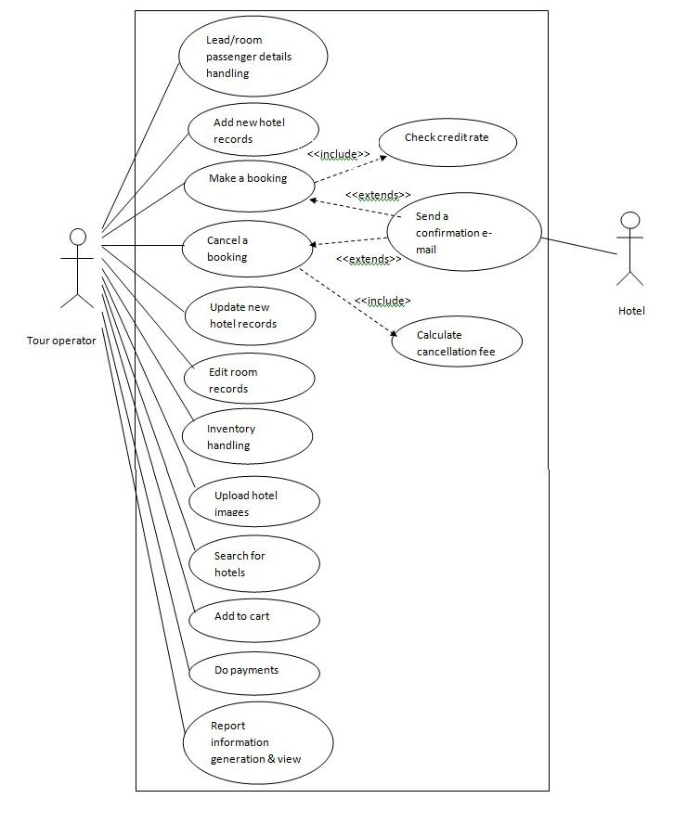

Figure22: Use Case Diagram - 2

Use Case Scenarios

- Add new hotel records
User case name: Add new hotel records
Actor: Tour Operator
Main flow of events:
- The use case begins when the Tour Operator gets new hotel details from the hotel itself.
- Tour Operator checks whether the details are correct for each hotel.
- Tour Operator adds the new hotel records to the system.
- The Use case ends when the Tour Operator checks the system records the details correctly.
Exceptions:
2.1 If a given hotel details are not correct, reject the hotel details and inform to the hotel to resend the correct details.
4.1 If the system didn’t get the records correctly, Tour operator rechecks the all records or delete the incorrect records and read to the system.

- Update new hotel records
User case name: Update new hotel records
Actor: Tour Operator
Main flow of events:
- The use case begins when the Tour Operator gets the new hotel details from the hotel itself.
- Tour Operator checks the details of each hotel.
- Tour Operator adds records to the system.
- Tour Operator checks the system records whether the details are correctly added.
- The Use case ends when the Tour Operator updates the records to the system.
Exceptions:
2.1 If given hotel details are not correct, reject the hotel details and inform to the hotel to resend the correct details.
4.1 If the system didn’t get the records correctly, Tour Operator rechecks all records or deletes the incorrect records and read to the system.

- Check login records
User case name: Check login records
Actor: Internal User
Main flow of events:
- The Use case starts when the Manager login to the system and checks the users.
- The Use case ends when the Manager monitors the system access logs.
4. Cancel a booking
Use case name: Cancel a Booking
Actor: Tour Operator
Main flow of events:
1. The Use case starts when the customer asks the Tour operator to cancel a booking.
2. Tour Operator asks the customer to tell the booking Id.
3. Customer tells the booking Id and the tour operator enters it to the system.
4. The use case ends when System removes the reservation with the specified booking Id from booking list and informs about the successful completion of cancellation.
Exceptions:
4.1 System calculates relevant days from the booking date and calculates relevant charges as it is indicated in cancellation policy and deducts it from booking paid.

5. Make a booking
Use case name: Make a booking/ reservation
Actor: Tour Operator
Main flow of events:
1. The use case starts when Customer selects a hotel and gives itinerary (days of stay at a hotel)
2. System searches for room details.
3. System presents room types and tariffs.
4. Customer selects room and confirms tariff.
5. System records customer's name and address
6. Tour Operator confirms booking on system.
7. The use case ends when System generates confirmation receipt.

6. Upload Hotel Images
Use case name: Upload Hotel Images
Actor: Tour Operator
Main flow of events:
1. The use case starts when Tour operator clicks upload image button to the relevant hotel.
2. The system prompts the tour operator to upload images.
3. An album is created to the relevant hotel with the images uploaded.
4. The album will be visible to the relevant hotel thorough the system.
5. The use case ends when Tour operator is informed of a successful outcome.
Exceptions:
3.1 If the system finds out the images were not in correct format it prompts to the tour operator.
3.2 The tour operator checks and re upload the images.

7. Update/Edit room records
User case name: Update/Edit room records
Actor: Tour Operator
Main flow of events:
1. The use case begins when the Tour Operator gets the new room details from the hotel itself.
2. Tour Operator checks the details of each room for relevant hotel.
3. Tour Operator adds records to the system.
4. Tour Operator checks the system records whether the details are correct.
5. The Use case ends when the Tour Operator updates the records to the system.
Exceptions:
2.1 If given room details are not correct, reject the room details and inform to the hotel to resend the correct details.
4.1 If the system didn’t get the records correctly, Tour Operator rechecks all records or deletes the incorrect records and read to the system.

8. Inventory Handling
User case name: Inventory Handling
Actor: Tour Operator
Main flow of events:
- The Use case starts when the Tour Operator login to the system and gets the inventory details for rooms and hotel details.
- After selecting the room, Tour Operator has to select the relevant month.
- The values will be displayed as a calendar by the system.
- The Use case ends when the Tour operator enters the Inventory / Rate into to relevant field and saves it.
Exceptions:
4.1 Inventories & Rates will be managed separately for adults and children.

9. Tour operator account creation
User case name: Tour operator account creation
Actor: Internal User
Main flow of events:
1. The use case begins when the Internal User gets new Tour Operator details when a new Tour Operator is assigned.
2. Internal User checks whether the details are correct for new Tour Operator.
3. Internal User adds the new Tour Operator records to the system.
4. The Use case ends when the Internal User checks the system records and whether the details are entered correctly.
Exceptions:
2.1 If given Tour Operator details are not correct, reject the Tour Operator details and inform to the Tour Operator to resend the correct details.
4.1 If the system didn’t get the records correctly, Internal User rechecks all records or delete the incorrect records and read to the system.

10. Internal User account creation
User case name: Internal User account creation
Actor: Internal User
Main flow of events:
1. The use case begins when an already existing Internal User gets new Internal User details when a new Internal User is assigned.
2. Internal User checks whether the details are correct for new Internal User.
3. Internal User adds the new Internal User records to the system.
4. The Use case ends when the Internal User checks the system records and whether the details correctly are entered correctly.
Exceptions:
2.1 If given Internal User details are not correct, reject the Internal User details and inform to the Internal User to resend the correct details.
4.1 If the system didn’t get the records correctly, Internal User rechecks all records or deletes the incorrect records and read to the system.
11. Tour Operator Contract Updating
Use case name: Tour Operator Contract Updating
Actor: Internal User
Main flow of events:
1. The use case starts when the Tour Operator requests for contract updating or renewal.
2. The Internal User checks the system for The Tour Operator's contract status.
3. The system gives contract details for the relevant Tour Operator.
4. The Internal User updates contract details if the Tour Operator has fulfilled the previous contract.
5. The use case ends when the system prompts successful outcome.

12. User Password Reset
Use case name: User Password Reset
Actor: Internal User
Main flow of events:
1. The use case starts when a request is made for reset the password.
2. The system gets relevant from keypad.
3. The system asks the Internal/User Authenticator to validate the inputs.
4. If the inputs are valid The Internal User/Authenticator returns the valid id and the password via email to relevant user.

13. Lead Passenger/Room passenger details handling
Use case name: Lead Passenger/Room Passenger details handling
Actor: Tour Operator
Main flow of events:
1. The use case starts when the system gets the relevant personal information from keypad.
2. The system sends the personal information to Reservation Controller sub system.
3. The Reservation controller sub system sends the personal information
to the DBHandler subsystem.
4. The use case ends when DBHandler inserts the personal information into Data base.

14. Add Contract details
Use case name: Add Contract details
Actor: Internal user
Main flow of events:
- The use case begins when the Internal user add the contract details to the each Tour Operator to the system.
- Internal User updates the time duration of the contracts of Tour Operators.
- The Use case ends when the Internal User edits the expired contract details.
Exceptions:
2.1 If a Tour Operator fails within the contract duration, the Internal User informs the Tour Operator.
2.3 Internal User gives approval to hand over a new contract if Tour Operator requests for a new contract.

15. Update/Edit account records
User case name: Update/Edit account records
Actor: Internal User
Main flow of events:
1. The use case begins when the Internal User gets the user details from the users.
2. Internal User checks the details of each user.
3. Internal User adds records to the system.
4. Internal User checks the system records whether the details are correct.
5. The Use case ends when the Internal User updates the records to the system.
Exceptions:
2.1 If given user details are not correct, reject the user details and inform to the user to resend the correct details.
4.1 If the system didn’t get the records correctly, Internal user rechecks all records or deletes the incorrect records and read to the system.

16. Search for Hotels
Use case name: Search for Hotels
Actor: Tour Operator
Main flow of events:
1. The use case starts when a customer comes for do a booking.
2. The Tour Operator asks him/her about the destination.
3. Tour Operator goes to the Booking Engine (search screen) and enters the details of the destination.
4. System will go through the hotels & find the hotels which will match the search criteria.
Exceptions:
4.1 If a hotel needs to come for the results then that hotel should contain balanced inventories & rate bigger than zero to get that hotel into the results.

17. Add to Cart
Use case name: Add to cart
Actor: Tour Operator
Main flow of events:
1. The operator will click add to cart button on the hotels that the client needs.
2. For every new booking process the system will generate a transaction key and it will be maintained from search to reservation.
3. When the Tour Operator adds the hotel into the cart, cart will be auto synchronized & update the values through the system.
4. The Tour Operator can always add hotel to the cart & remove hotels from the cart.
5. The use case ends when the system displays hotel details from the cart items also.

18. Payment
Use case name: Payment
Actor: Tour Operator
Main flow of events:
1. The use case starts when the Tour Operator enters the payment section.
2. The system will generate the cancellation policy according to the given check in date & the booking date & will display in the payments page.
3. Then the Tour Operator clicks on the Confirm Payment button.

19. Report Information Generation and View
Use case name: Report Information Generation and View
Actor: Internal User and Tour Operator
Main flow of events:
1. Tour Operator/Internal User views the Hotel/Room occupancy ﬁgures.
2. Tour Operator/Internal User views ﬁnancial information.

Other Nonfunctional Requirements

Performance Requirements
The performance requirement for this project is that so all the users will be able to handle functions in the system. We are to make the system comply with using the existing manual system so no errors would occur. So it should have to carefully manage. We are to make sure all those entities are properly connected via the right relationships.

Performance requirements define acceptable response times for system functionality.

- The load time for user interface screens shall take no longer than two seconds.
- The log in information shall be verified within five seconds.
- Responses to queries shall take no longer than 7 seconds to load onto the screen after the user submits the query.
- The system shall display confirmation messages to users within 4 seconds after the user submits information to the system.

Logical Database Requirements
The logical database requirements include the retention of the following data elements. This list is not a complete list and is designed as a starting point for development.

Booking/Reservation System
Customer first name
Customer last name
Customer address
Customer phone number
Number of occupants
Assigned room
Default room rate
Rate description
Guaranteed room (yes/no)
Credit card number
Confirmation number
Automatic cancellation date
Expected check-in date
Expected check-in time
Actual check-in date
Actual check-in time
Expected check-out date
Expected check-out time
Actual check-out date
Actual check-out time
Customer feedback
Payment received (yes/no)
Payment type
Total Bill

Design Constraints
Travel Map Asia Offline Booking System shall be a stand-alone system running in a Windows environment. The system shall be developed using Java and PostgreSQL database. Designer should decide on what information to show and what information should not show on the screen also in an attractive way. Interfaces should be very user friendly by the same time it should be informative and attractive. Designer should follow a very consistence design throughout the system and should choose a very promotional and state of art design. Navigation within the system must be consistence as well. Navigation should be user friendly and should be able to find wanted information in few clicks.

Standards Compliance
There shall be consistency in variable names within the system. The graphical user interface shall have a consistent look and feel.

Safety Requirements
Safeguard of the product, its users and ethical issues should be given consideration when using this system. Any attempt in using the system in an illogical way is prevented within the system. The constraints take effect on shaping the software to a more trustworthy, reliable, and genuine one. In the design phase many constraints, rules and regulation are defined. Any potential actions against these strategies make restrictions to the users. The other safety regulation for this system will be that all of the reports that are being generated will be in soft copies so they need to regularly back up. In our system we designed it as 24h timed back up plan. Every day at midnight system will automatically get the back up of all the functions which have happened that day. The users of the system are given a manual to handle the software and therefore will accordingly have a good idea about the system and its features.

Security Requirements
The system is designed that the internal user will have full authorization. It will be internal user's responsibility to give permission to each and every tour operator, while they are added to the database.
If a user enters a password and the software checks its validity. If the password is valid then option is given to change password, otherwise an error message is displayed. There is an option for password recovery, log out, log in, new users sign in. Internal User and Travel Operators can also update changes in the system after login relevant to their access permissions.

Software Quality Attributes
Security
Internal Users and Tour Operators will be able to log in to the Travel Map Asia Offline Booking System. Tour Operators will have access to the Reservation/Booking subsystems but not for Management subsystems. Internal Users will have access to the Management subsystems but not for the Reservation/Booking subsystems. Access to the various subsystems will be protected by a user log in screen that requires a user name and password. Password should be encrypted and store in the database. Integrity of the data must be protected at all cost.

Reliability
Reliability of a system is the ability to perform its normal operations with minimum failures over a specified time in a given environment. The system provides smooth and simple operations. If an incorrect operation is performed in a particular module, the system will inform the user with proper error messages.

Maintainability
Travel Map Asia Offline Booking System is being developed in Java. Java is an object oriented programming language and shall be easy to maintain. Software should be written in such way that it may evolve to meet the changing needs of customers. This is a critical attribute because software change is an inevitable consequence of a changing environment. So considering the future potential use of the system, the application is designed in a way that it assists for updates of the software in future. The code is commented wherever it is necessary, especially in critical and complex code segments. This will help the developers or maintaining team for modifications in future.

Correctness
The correctness of the system should be of 90% or above when generating reports.

Availability
Availability of system is that a system is in working condition at a given time and it should be able to deliver the required services. That is a system should be available within minimal system down time or without having any system failures for long time. Travel Map Asia Offline Booking System should be available whenever a user wants to use it.

Dependability
Software dependability has a range of characteristics, including reliability, security and safety. Dependable software should not cause physical or economic damage in the event of system failure.

Efficiency
Software should not make wasteful use of system resources such as memory and processor cycles, efficiency therefore includes responsiveness ,processing time, memory utilization, etc...

Usability
Software must be usable, without undue effort, by the type of user for whom it’s designed. This means that is should have an appropriate user interface and adequate documentation.

Portability
Travel Map Asia Offline Booking System shall run in any Microsoft Windows environment that contains Java Runtime and PostgreSQL database.

Business Rules
Illegal duplication of the reports should be strictly dealt with.
The internal user should have full details of the travel operator while a travel operator is getting registered to the system.
Contract Policy and International Contracting
Local tax rates
Automated emails
Payment processors (including payment gateway)
Localization (taxes and currency conversion)

Other Requirements
PostgreSQL 9.0 Database Management System requirements
- Windows XP(Service Pack 3) or higher version
- 32 bit CPU or 64 bit CPU
- GNU make version 3.80 or newer*
- Minimum 200MB disk space(for installation only )
- 512MB or higher system memory
*for Unix OS version
JDBC4 PostgreSQL Driver requirements
The following tools are required to build and test the driver:
- Java 2 Standard Edition Development Kit At least JDK 1.2.
- Apache Ant At least 1.5.
- JUnit At least 3.7.
- GIT
- User should have basic knowledge in English language to understand the basic software operations.
- User must have a knowledge in basic computer concepts.
- Software needs an internet connection.

- Backup and recovery
Keep backups of all data files in a separate directory/drive.
Frequently auto-save information, in the case of a system crashing, etc.

- Data migration
The concept of data migration is important to ensure that the data that is being entered and stored today could be accessed after even several years.

- Data retention
Maintaining a log file for each user logging in and also maintaining the account details of the users who have finished the accounts could be obtained from reports.

- User training
Clients must be trained to operate the software in creating new accounts and performing report operations.

- Installation
A conducive environment for the efficient running of the system is always recommended. And all unauthorized access should be restricted.

Appendix A: Glossary
Glossary information is provided withn the context of this document where ever it should be specified.

Appendix B: Analysis Models
Entity Relationship Diagram
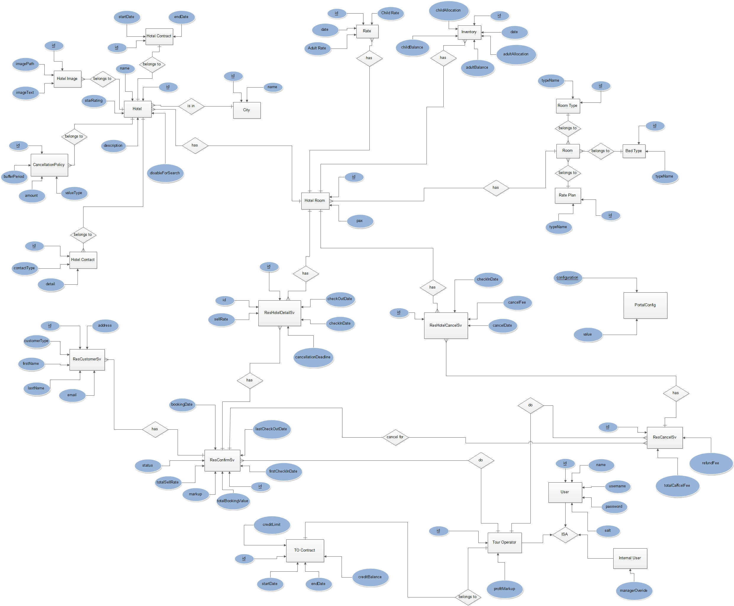

Activity Diagrams

Hotel | Tour operator
Send new details | Get new details from hotel  Check whether details are correct  Enter details to the system  Check the entered correctly
Add New Hotel Records

Update New Hotel Records

Hotel | Tour operator
Send new details | Get new details from hotel  Check whether details are correct  Enter the details  Check the entered details are correct  Save the entered details

Check Login Records

Manager | user
Login to the system  Check users  Monitor the system access logs  Check the logs  Send a message to the user | Receive the message

Cancel a Booking

Tour operator | Customer | Hotel
Ask for reservation ID  Enter the reservation ID to system  Cancel the reservation  Calculate cancellation fee  Get the reservation details  Save details  Send a confirmation e-mail | Ask for cancel the reservation  Give the reservation ID  Pay the cancellation fee | Receive the e-mail

Make a Booking

Tour operator | Customer | Internal user | Hotel
Ask for destination  Search for hotel s match with the destination  Search room details  Calculate total fee  Compare the total fee with the current credit limit  Ask for update credit balance  Send a confirmation e-mail | Ask for a reservation  Give destination details  Select a hotel  Select room types | Update credit balance | Receive the e-mail

Inventory Handling

Tour operator
Login to the system
Get inventory details
Select the month
Select a room
Enter the values to the relevant field in the inventory
Get the values displayed about room
Save the details

Tour operator account creation

Internal user | Tour operator | Hotel
Receive the details  Check the details  Enter the details  Validate the details  Send login details to the tour  Send a confirmation e-mail | Receive the login details  Send details to the internal user | Receive the e-mail

Internal user account creation

Manager | Internal user
Receive the details  Check the details  Enter the details  Validate the details  Send login details to the tour | Receive the login details  Send details to the internal user

